Misc. Typing Notes
Contents
PROPOSED INSURED CODES / MORTGAGEE CLAUSE CODES: 3
RELOCATION FILES: 3
MULTIPLE ADDRESSES / EDIT MODE: 3
PERSONAL REPRESENTATIVE 3
TAXES 4
PARTIALLY DELINQUENT TAXES: 4
BFC22: 5
SELLER FINANCING / SELLER CARRYBACK 5
VACANT LOTS 5
construct-to-perm loan 6
NOTES IN ADDRESS LINE 6
REVERSE MORTGAGE (refis and purchases 6
CLEARING ON SELLER SIDE ONLY 6
CHANGING TRUST ACCOUNT ON A FILE 6
Adding a 2nd address in a different county 6
Commercial 7
Commercial Notes: 7
Underwriter File Colors 7
Terminology 7
Keyboard Shortcuts 7
Wasatch Peaks Ranch 8
Internal Split/Same Escrow (IS/Same Escrow): 8
Vesting 8
Miscellaneous 8
Builders 8
TRUST INFO 9
Suffix Changes 9
Jr. Policies/Junior policies 9
Selecting Policy Types 10
Extended coverage owners policy: 10
Developers Rate 10
Creating an escrow file 10
Removing pop-up note in Select: 10
Lis Pendens code 10
Hyperlinking: 11
UDOT: 12
Parcel Removed Before Issuing Final Policy 12
REFINANCES 12
CHANGING REAL PROPERTY REPORT TO COMMITMENT 12
ALLIANT 13
Switching a file's Policy Type from loan only to any other type 13
CITY REPORTS 14
Multiple Addresses 14
DTSRCL and Line of Credit 15
Legal Descriptions 15
Parcel Removed Before Issuing Final Policy 15
Type of Deed for Requirements 15
ASSUMPTION OF LOAN: 15
Requirement and Exception Codes 15
ALTA 39 2021 POLICIES 16
ENDORSEMENTS 16
LLC with a Homeowners Policy: 16
SCR Endorsements: 16
Calculating Endorsements 16
CONDO ENDORSEMENTS 17
BALLOON ENDORSEMENTS 17
REVERSE MORTGAGE 17
Updating a Closed File 17
Default Codes 18
PR NOTES/DOCUMENT NOTES 18
EASEMENTS 18
RESOLUTION 19
CERTIFICATE 19
ASSIGNMENTS 19
AFFIDAVIT 20
LEASES 20
NOTICES 20

PROPOSED INSURED CODES / MORTGAGEE CLAUSE CODES:
FULL - its successors and/or assigns as their respective interests may appear
ISAOA - its successors and/or assigns
ISAOA/ATIMA - its successors and/or assigns as their interest may appear
ABBRE - whatever is typed in the clause box in the lender contact
VA-ISAOA - and/or the Secretary of the Department of Veterans Affairs, its successors and/or assigns

ISAOA -- do not spell out for: Quicken Loans, Rocket Mortgage, Canopy, Houzd

RELOCATION FILES:
Attach tax cert and search, then email escrow and let them know they're in Select; ask them to get us the Tax Info sheet. Then when you send it to proofing, write tax cert and tax info sheet on the cover page. Also: Make sure to add their file/order number in "email subject line" -- either use escrow comments or project name, depending on where the order number has been put into select. (default to escrow comments if it's in both)

No LLCRAG for relo. company. Don't need to add vested owners via edit mode on last page. Relo company will be the " contact.

TITLE ONLY FILES: No fee sheets. No templates unless it's Kristi's

MULTIPLE ADDRESSES / EDIT MODE:
On files that have multiple addresses from different cities, follow the normal "edit mode" practices for now, as long as Schedule A still looks clean - and only show addresses from different cities on 3 or less parcels. If adding multiple addresses pushes information onto a second page we might want to take another approach or just not show any addresses, but we'll cross that bridge when we see it!

PERSONAL REPRESENTATIVE

Personal Representative's Deed from ____, personal representative of the Estate of ___, Probate Case No. ____, ___ District Court of Utah vesting fee simple title in ____.

_____, Personal Representative of the Estate of ______, Probate Case No. _____, ___ District Court of Utah
"Recordation of satisfactory Affidavit of Death or Death Certificate for [deceased person's name]"

Kenneth Hopps aka Kenneth J. Hopps, as to a 50% interest and Kenneth J. Hopps, Personal
Representative of the Estate of Patricia Hopps, Probate Case No. 253900372, Third Judicial District Court of Utah, as to a 50% interest

1. Warranty Deed from Kenneth Hopps aka Kenneth J. Hopps, as to a 50% interest vesting fee simple title in Tyler Quinn.
2. Personal Representative's Deed from Kenneth J. Hopps, Personal Representative of the Estate of Patricia Hopps, Probate Case No. 253900372, Third Judicial District Court of Utah, as to a 50% interest vesting fee simple title in Tyler Quinn.

TAXES

PARTIALLY DELINQUENT TAXES:
Taxes for the year 2023 are accruing as a lien not yet due and payable under Parcel No. XX-XXX-XXXX.

Taxes for the year 2024 are accruing as a lien not yet due and payable under Parcel No. 01-506-0232.

Taxes for 2023 were assessed in the amount of $___, with an amount of $___ paid late, leaving a lien past due and payable in the amount of $___, plus penalties and interest under Parcel No. _____.

Taxes for the year 2022 were assessed in the amount of $___, with a partial payment in the amount of $___, leaving a lien past due and payable in the amount of $___, plus penalties and interest under Parcel No. ____.

DAVIS COUNTY: ok to show 3 amounts instead of the assessed/paid as same amount, and clarifying it was paid late

DEL ABATEMENT:
Taxes for the year 2023 are accruing as a lien not yet due and payable under Parcel No. 16-17-476-010.

Taxes for the year 2022 were assessed in the amount of $0.00. After applying an abatement in the amount of $0.00, with a partial payment in the amount of $0.00, the remaining balance of $0.00 is a lien past due and payable in the amount of $0.00, plus penalties and interest under Parcel No. 16-17-476-010.

PREPAYMENT:
NOTE: Taxes for the year 2025 show a prepayment in the amount of $0.00

NEW PARCELS FOR NEXT YEAR:

NOTE: Taxes for the year 2026 will be assessed under Parcel No. 21-01-228-098.

Taxes for the year 2025 are accruing as a lien not yet due and payable under Parcel No. 21-177-0024.

Taxes for the year 2024 were assessed in the amount of $5,902.57. After a partial payment in the amount of $122.00, the remaining balance of $5,780.57 is a lien past due and payable, plus penalties and interest under previous Parcel No. 21-177-0020. (covers this and other land)

(LATE PAYMENT)
Taxes for the year 2024 were assessed in the amount of $2,030.80. After a late payment in the amount of $2,030.80, the remaining balance of $20.51 is a lien past due and payable, plus penalties and interest under Parcel No. 16-20-359-001.

BFC22:
Put in Project Name line and new Other Contact lookup code

SELLER FINANCING / SELLER CARRYBACK:
if it's uninsured, treat it like cash -- use cash fees; however, still add dtsrnew.
if it's insured, add the seller as the lender contact and include the loan amount. No fee sheet, no endorsements.

1.10.24: From now on, we need to issue standard coverage on seller-financed loan policies.
There are now standard loan rate tables in Select. If a file was entered before today, you may need to select the "Default" coding shown in the screenshot below. Otherwise, the policy code on Schedule A will pull correctly.

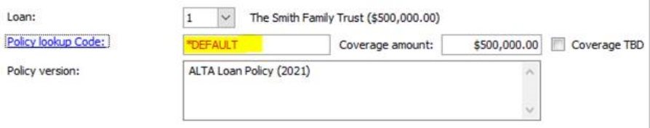

Seller Carryback – Extended Coverage Loan Policies

ALLIANT
- Not available
FIDELITY (INCL. CHICAGO & COMMONWEALTH)
- Generally, not available
- Willing to review requests, with a clear understanding of why extended coverage is needed
FIRST AMERICAN
- No official stance, but prefer to not offer
- May be possible to remove some of the standard exceptions with u/w approval
OLD REPUBLIC
- Generally, not available
STEWART
- Not available
WESTCOR
- Generally, not available
- Would potentially offer extended coverage with a survey

VACANT LOTS: (Normally no Endorsements on Vacant Lots (builder and residential))
No fee sheet.
For Vacant Lots on FATCO: Default to adding the following endorsements--
-ALTA 8.1
-FA 31 (to replace the ALTA 9)
-FA 32 (to replace the ALTA 22)
Vacant lot endorsements: if we don’t have any lender info, don’t include any endorsements. We’ll add these in when we get the lender order and know what they want us to include.

(covers part of said Land with other land)

construct-to-perm loan: It has to be extended loan on FATCO. If it's ORT or Stewart, it can be refi rate.

NOTES IN ADDRESS LINE: (ex: "3rd takedown of 39 1/3 acre lots and 4 1/2 acre lots") just move these to the 2nd address line and it shouldn't pull on the commitment (as long as there isn't an address in the 1st line)
LOT LOANS: -no fee sheet. -no endorsements.

REVERSE MORTGAGE (refis and purchases):
Use HUD fees. If file is a CD toggle over to a HUD file. Add to standard 3 endorsements: 6.2, 14.3 (add charge amounts). (can keep alta 5 if it is applicable)

CLEARING ON SELLER SIDE ONLY: if they are asking if something is sufficient to clear an exception, you can fwd the email to whoever searched it, attach their response in select (as Clearing #xx) and then just file it away, since on seller side files they don't need things to cleared until closing. (however, if an agent, for example, is asking for something to be cleared, we would still update the commitment)

we don’t insure what the percentage of ownership interest is, so the Proposed Insured will simply reflect the 2 trusts, as tenants in common.

CHANGING TRUST ACCOUNT ON A FILE:
We cannot change this after money's been put in the account, so we have to create a new file if they want the account changed. We have 2 accounts: Wells Fargo and Zions. Before we give escrow the new file number:
-Go to Register (top left). Change Trust Account to WELLS (if that's what we are changing it to) -- you can use the drop-down here.
-Go to Order Information. Custom Fields > Scroll to bottom. Trust Account: hard type "WELLS" (no drop-down option. match the spelling of the Register option).
If you need help, you can ask Phoebe, Justin, or Eli.

Adding a 2nd address in a different county:
  - Ex: 159309
  - Add Address 1 (Parcel 1) in the first line. Add Address 2 (Parcel 2) in the second line. Add both cities in the City field (ex: West Point and Roy). Just add one zip code.
  - In edit mode, you will format the addresses:
    - Address 1
City 1, UT Zip (Parcel 1)

Address 2
City 2, UT Zip 2 (Parcel 2)
  - You won’t need to format the cover page since it won’t be sent out to anyone.
Commercial:
- Do not include a chain.
- Endorsements should always be moved to an Exhibit.
- Standard endorsements are 8.2, 9, and 22.
- Link everything, including the vesting document.
- Scan SCR Filing
- Commercial Bubble & Order Type
- EXAMPLE FILES: 186854, 186393, 186284, 186283

Commercial Notes:

- Fee Simple as to Parcel 1; Easement as to Parcel 1A
- L2 – Underwriter
- Commercial Fees
- SWDRSWD

Underwriter File Colors

Alliant - Grey
FATCO/First American - Blue
ORT/Old Republic - Green
Stewart - Red
Fidelity – Lavender/purple
Chicago - Pink
Westcor - Brown
Commonwealth - Orange

Terminology

JT - Joint Tenants
UW - Underwriter
PR - Preliminary Report
PSA - Purchase Sale Agreement
OP - Owners Policy
CPL - Closing Protection Letter
UDOT - Utah Department of Transportation
FSBO - For Sale by Owner
EOD - End of Day
Et Al - And Others
Vertical - Construction Loan
EM - Earnest Money

Keyboard Shortcuts

- Shift + F3 = Change case
- F7 = Spell check
- F2 = Clear (in select)
- F9 = Open menu/drop-down
- Ctrl + A: Selects all content on the current line
- Ctrl + C: Copies selected items to the clipboard
- Ctrl + V: Pastes content from the clipboard
- Ctrl + X: Cuts selected text
- Ctrl + Z: Undoes the last action
- Ctrl + Y: Redoes the last action
- F1: Opens the Help screen for most programs
- F2: Renames a selected file or folder
- F3: Opens the search feature for the active application
- F11: Maximizes the window
- Windows logo key + Tab: Opens Task View
- Windows logo key + D: Displays or hides the desktop
- Alt + Tab: Switches between open apps

Wasatch Peaks Ranch

- You are okay to remove exceptions without using DEL on these BEFORE a buyer is added ***After a buyer's been added, show DEL***
Make sure to double-check tax serial number – (as of 12/21/22 should be “11-“ rather than “10” or “01”)
- Send to Meggi only (okay to include Sarah, Donna, etc.) (never a cover sheet)
- Always treat as a rush
- Alisa prefers to proof these (new orders and updates)

Internal Split/Same Escrow (IS/Same Escrow): forward all emails to Alisa when there is an update. (you can still do the amendments, but she needs to know of any changes that are happening.)
add the IS file numbers to the Project Name field for both files.
Vesting: Use the drop-downs as much as possible in the Order Contacts page. Don’t worry about matching capitalization on “an unmarried…” etc. Also okay to leave off “as” if it says “as joint tenants”.

Miscellaneous
  - If there is a loan policy that is not showing yet: keep it as Owners Only in Select until they want it showing.
Forward cancellations to Alisa if the order is not yet typed

Builders

- Now that we are showing due amounts, I wanted to remind you that we do not show the tax amount on builder files for previous numbers that cover other land. Here’s an example:

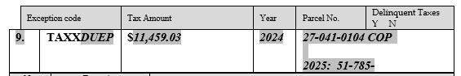

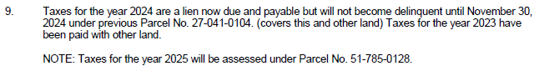
TRUST INFO:
When a trust is the buyer, match the name of the trust exactly. Some trust documents will specify how they want title to be held. We do just the trust name in the Contact field, and add the trustees as contacts below.
If there are two dates, (dated ___ and amended___) show both.

Keep it as Marcus Family Living Trust, dated February 16, 2006. If there is a specific date for the amendment, you should include it.

Suffix Changes: Change marketing source if the last letter of the suffix changes. The source may also change. Check in the email or ask escrow for the source.

Jr. Policies/Junior policies:
Changing a File to a Junior Policy
- Add the email in Select as "Update (#) Junior Policy"
- Find the yellow file. Switch it to a blue First American folder. Add a new file label and a Junior Policy sticker.
- In the Project Name line, add "EXPRESS" (replace REV).
- Change Order Type to "Title and Escrow".
- Change Product Type to "Express".
- Change Policy Type to "Loan Only".
- Change Transaction Type to "Equity".
- Toggle to CD if needed.
- Last, bring the file to Alisa. 😊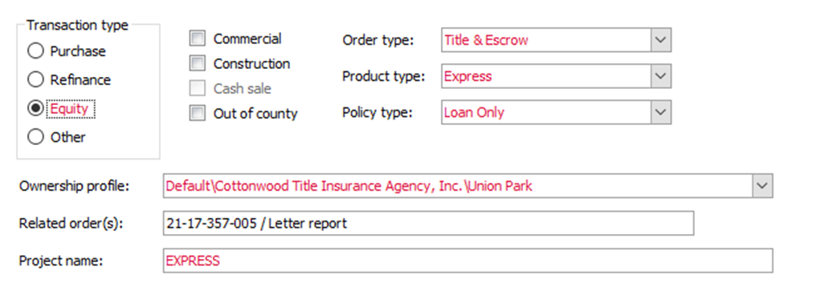

Selecting Policy Types
Extended coverage owners policy: To add the extended coverage requirements, Hit “++”, search “ext”, double-click to add -1, 2, 3, and 6

Developers Rate
If you have to use Developers Rate, the file must be on Old Republic
If you change the escrow officer on a file, you have to update it in 2 spots: on the cottonwood express page, and in the settlement agent contact page.
If you change amounts, make sure to reprice endorsements
If we are only removing a policy, forward the email to Alisa unless we have other items to update
Creating an escrow file:
  - Get a manila folder. Print a label, barcodes (escrow), and the email. Bind it in the folder; no need to add to select.

Removing pop-up note in Select:
When there is a MIDXSSN requirement and exception, there will also be a pop up note that comes along with it. If we get the info for the buyer/seller we don’t need that pop up anymore. You can go into the note and unclick the box. UNEDIT PR to pull names through,

Lis Pendens code
relrlp

Release of that certain Lis Pendens shown herein as Exception No. xx, and Dismissal with Prejudice of, or entry of a final nonappealable order resolving all claims in, that certain Case No. xxxxxx filed in the xxxxx Court, xxxxx County, State of Utah.

Hyperlinking:
Please follow the typing format below for Automation to link exceptions without Entry Numbers. Do not include “of Liens and Leases,” etc.
These older documents without an Entry No. need to be saved as Book-Page (i.e., Y-157).
New Hyperlinking Process
- Saving Documents
- Save all exception documents to the folder in Select labeled Exception Documents
- Documents need to be saved as Entry No. only (i.e., 20220011428)
- Utah County documents need to be saved as Entry No.-year (i.e., 95066-2015)
- If the Utah County document is older than 2000, we still need to include the year
- Older documents without an Entry No. need to be saved as Book-Page (i.e., Y-157)
- Do not include zeros at the beginning of Entry No.

- To unlink an exception, remove the link manually and add DO NOT HYPERLINK to the "Comment" section
Select Process
- Drop documents into the FileZilla folder labeled, Documents
- Documents cannot be saved with the same name. If the document is already in the folder, click Skip
- After the PR is typed, save Select, refresh the changes made by Automation, and the links will appear automatically
- Continue to hyperlink the vesting and legal (if needed) by copying and pasting the hyperlink. Save these documents in the Documents folder as vesting-file number (i.e., vesting-160655-LMV)
- Search for these links by using CTRL F on http://docs.cottonwoodtitle.com/Documents/
- Check your links! Automation will link every exception, but if the document is not in the folder, the link will not be active

Notes
- If you upload a plat to the Documents folder, it should not include an arrow pointing to a lot
- We only need to hyperlink the plat on commercial files
- Hyperlinking Automation applies to any file entered Thursday, August 25, or later (file 162119-KMF and later)
- Re-do the WDRSWD requirement code on any files with the coded language

UDOT:
the “Transaction Type” and “Order Type” for UDOT files should mirror the type of property being insured. For example, if it is UDOT purchasing from a homeowner, the file should be Residential. If UDOT is purchasing from a commercial owner, it should be marked as Commercial.

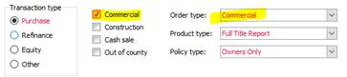

UDOT LEGAL LANGUAGE (ex. 153564-kap)

PARCEL 3: (NOTE: Parcel 3 and any reference to Parcel 3 made herein will be removed BEFORE issuing a final Policy of Title Insurance)

UDOT PARCEL NO. _____

Parcel Removed Before Issuing Final Policy
(BOLD AND UNDERLINE)(can be on same line as “PARCEL X” or on its own)
(NOTE: Parcel 4 and any reference to Parcel 4 made herein will be removed BEFORE issuing a final Policy of Title Insurance)

For an easement only file: Change the wdrswd requirement to the following:
Easement from _____ to ___ to create the Easement Estate to be insured hereunder.

Okay to renumber requirements on older files.

REFINANCES
In order to give a refi rate, all of our UW’s require a payoff of an existing deed of trust. FATCO is the only UW that allows a refi rate when there is no payoff of an existing deed of trust. On 162890, there are two deeds of trust, which would normally correlate to a payoff, however, the two deeds of trust name previous owners as the borrowers. Because the deeds of trust name previous owners, it means they should have already been paid off when the current owner bought the house, we just don’t have evidence yet. Because they should have previously been paid off, we aren’t doing a payoff for our current owner and that means the UW has to be FATCO to keep the refi rate.

CHANGING REAL PROPERTY REPORT TO COMMITMENT: (159091-tof)
  - We don’t need to apply a template
  - No fees
  - Extended rate, not refi rate (FATCO is the only underwriter that we can use the refi rate if they’re not paying off their current DT)
  - The settlement agent should be Erika, so her name pulls on the commitment

ALLIANT:
Please default to using the extended rate for the loan policy when issuing a loan policy with a simultaneous owner’s policy. We are not required to use the same agency rate and will only use it in special circumstances.

To clarify, please use the rates listed below:

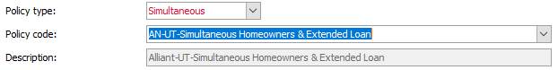

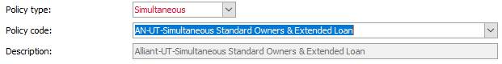

Switching a file's Policy Type from loan only to any other type:
Make sure to follow each of these steps in order:

1. In Cottonwood Express Order Entry screen, change the policy type from Loan Only to the new type needed.
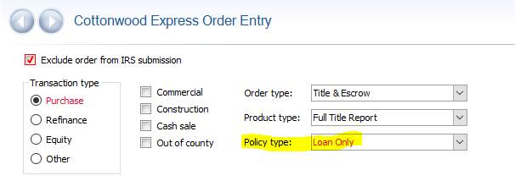

2. In the Title Insurance Premiums screen, change the Policy Type and Policy Code.
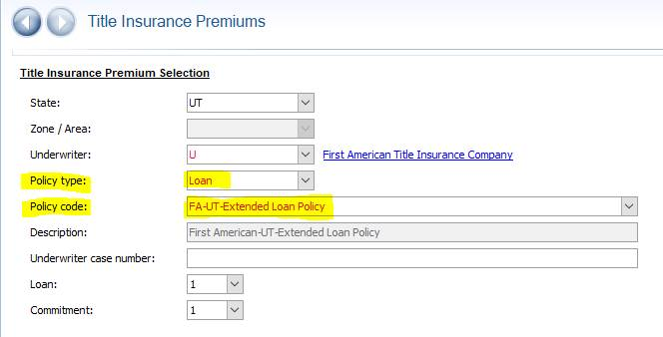

3. In Escrow/Closing > Additional Title Charges, delete each fee showing in the top section. (Click on the fee, then click the – button.)
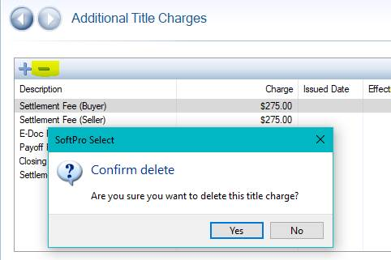

4. Apply the correct fee template.

CITY REPORTS:

- South Jordan – Real Property Report
- West Jordan – N/A Commitment
- Washington City – N/A Commitment
- Hurricane – N/A Commitment
- St. George – N/A Commitment
- La Verkin – Real Property Report
- Cities not listed should be okay with a RPR. (as of 1/2023 per Alisa)

Multiple Addresses
if we’re currently showing two addresses because it’s a corner lot and the lender order only shows one address, we match the lender order.

If there is information in the contract about how the equity will be split when a home is sold, then we don't need to worry about it -- we would only need to include that info as an exception if it was in a recorded document. Since it's just in the contract, that is among those parties to figure out amongst themselves.

DTSRCL and Line of Credit
DTSRCL – To be used on a purchase. The line of credit trust deed needs to be closed. This requirement needs to follow DTSRDOT.

Signed authorization from Trustor(s) closing any revolving lines of credit secured by deed of trust shown as Exception No. 12.

DTSRCLR – The “R” stands for refinance. The line of credit trust deed needs to either be closed or subordinated to the new trust deed being recorded in our transaction. This requirement can be used on its own.

Signed authorization from Trustor(s) closing any revolving lines of credit secured by, or a satisfactory reconveyance eor subordination agreement from the beneficiary of the Deed of Trust shown as Exception No. 12.

We do not show either of these requirements if we are using DTSRDOTP.

Legal Descriptions

Parcel Removed Before Issuing Final Policy
(BOLD AND UNDERLINE)(can be on same line as “PARCEL X” or on its own)
(NOTE: Parcel 4 and any reference to Parcel 4 made herein will be removed BEFORE issuing a final Policy of Title Insurance)

Type of Deed for Requirements
The type of deed to use is typically defined in Section 6.1 of the REPC. However, builder contracts (and commercial contracts) are usually different since they don't use the standard REPC, so our templates will already have the type of deed selected.
And if you type commercial files and want to match the deed before it comes to proofing, you'll be looking for a paragraph in the contract called "title to property" or "title insurance"

ASSUMPTION OF LOAN:
Document(s) sufficient to the Company for the purpose of evidencing the Assumption of the indebtedness secured by the Deed(s) of Trust shown herein as Exception No(s). 18.

Requirement and Exception Codes
PUR$XBUY: This item will show on Policy
SPRASSES: Payment of Special Assessments

ALTA 39 2021 POLICIES
I double-checked with Donna, who said that the ALTA 39 doesn’t apply to 2021 policies because it’s been built into the jacket.
The lender said the 39-06 endorsement is missing from the file. Will you please add it so I can get a Settlement Statement out to them?

ENDORSEMENTS
- Standard Residential Endorsements: ALTA 8.1, ALTA 9, ALTA 22
- Commercial Endorsements: ALTA 8.2, ALTA 9 and ALTA 22
- HOA/PUD: ALTA 5

LLC with a Homeowners Policy:
- First American: FA92
- Old Republic: ORT 4644
- Commonwealth: SE 430
- Westcor: EN-677
- Stewart: STG - Additional Insured
- Alliant: ANTIC
- Fidelity: SE 430

SCR Endorsements:
- Old Republic: 4637

- First American: UTSCR
- Stewart: STG UCR
- Fidelity: SE-260

Calculating Endorsements
Fidelity/Chicago/Commonwealth:
Owners Policy: Use Basic Standard Rate -- calculated off the standard owners policy
Loan Policy: Use Basic Standard Rate -- calculated off the standard owners policy
Stewart/Old Republic:
Owners Policy: Calculated off Standard Owners Policy
Loan Policy: Calculated off Extended Rate
First American:
Owners Policy: Use premium in Select
Loan Policy: Use premium in Select

Stewart Rate Manual
Here are a few key items to note:

- They have modified their basic table of rates
- A standard OP is now 100% of Basic
- Stewart has a Land Bank Rate
- To qualify for a subdivider rate, the number of lots is now two
- Stewart has a reissue discount
  - Residential 1-4 family only, when an owner’s policy was previously issued within five years

CONDO ENDORSEMENTS
- FATCO/Alliant: delete ALTA 22 and replace with ALTA 22.1
- Stewart/any other: replace ALTA 22 with CLTA 116.2
- All Condos add ALTA 4

These subdivisions should not get the PUD endorsement added on updates.

Henry Walker – Grayson Ridge West Phase 1
Century – Sunset Ridge Phase A Plat 7

BALLOON ENDORSEMENTS
Per First American:

Are the loan documents on the Fannie Mae form for a balloon mortgage and the mortgage or rider contains the provision relating to a conditional right to refinance and change of interest? IN my looking I found those same endorsements, but in reading some issuing guidelines it seems like if the documents are Fannie Mae forms, it should say at the bottom, then we would be good as well.

If the deed of trust is on a FNMA form we can issue the CLTA 111.9 or FA 36.1, The price is the same for each: $25 for residential and $100 commercial.

CLTA 100.19: Fidelity -- 20%, no max.

REVERSE MORTGAGE
(refis and purchases): Use HUD fees. Add to standard 3 endorsements: 6.2, 14.3 (add charge amounts). (can keep alta 5 if it is applicable)

Updating a Closed File

1. Print Commitment for the write-up.
2. Attach the update email as usual. Do not print the email.
3. Give to the searcher to update the effective date.
4. When typing, don’t change the vesting or add any documents that have to do with the closing – we are essentially pretending they didn’t happen yet. Add anything else that is unrelated to the closing. Print the new commitment when finished.
5. Give the loose commitment with the write-up (and cover page) to Alisa to proof.

Default Codes

MOM9785 - Momentum Loans
INTPOB - Intercap Lending
FIR508 - First Colony
RED109 - Redfin
CRO685 - Cross Country Mortgage
BRO145 - New American Funding
CEN298 - Century Communities
SECPO - Security National
ZIOPOB - Zions Bank
INS202 - Inspire Home Loans
NEW145 - New American

PR NOTES/DOCUMENT NOTES

EASEMENTS

Pole Line Easement in favor of Utah Power and Light Company to construct, reconstruct, operate,maintain and repair electric transmission and other equipment and incidental purposes, over, under and across a portion of the subject Land. Said Easement recorded October 2, 1969, as Entry No. 526240, in Book 926, at Page 436.

Easement in favor of Utah Power and Light Company to construct, reconstruct, operate, maintain and repair electric transmission and other equipment and incidental purposes, over, under and across a portion of the subject Land. Said Easement recorded June 20, 1991, as Entry No. 1143439, in Book 1602, at Page 141.

Easement in favor of Huntsville Town, a body politic of the State of Utah to lay, maintain, operate, repair, inspect, protect, install, remove and replace culinary water, pipe lines, valves, service lines, and other culinary water distribution and transmission structures and facilities and incidental purposes, by instrument recorded June 16, 2003, as Entry No. 1947620, in Book 2385, at Page 2095.

Public Utility Easement recorded March 13, 2024 as Entry No. 3317748.
Temporary Easement in favor of Utah Department of Transportation for the construction of improvements incident to SR-39; MP 19.36, Construct Roundabout, known as project number F-0039(43)19 and incidental purposes, by instrument recorded March 13, 2024, as Entry No. 3317749.

(Easxplat with subdivision and recording info) Easements, notes and restrictions as shown on the recorded plat for Wyndom Square Commercial Subdivision Phase 2 recorded February 4, 2008 as Entry No. 2338844 in Book 4462 at Page 1338. (affects Parcel 1)

(Easxplat with subdivision and recording info) Easements, notes and restrictions as shown on the recorded plat for Wyndom Square Commercial Subdivision Phase 2 Amended recorded July 16, 2018 as Entry No. 3104989 in Book 7057 at Page 108. (affects Parcels 2 and 3)

(Easxplat with subdivision and recording info) Easements, notes and restrictions as shown on the recorded plat for Wyndom Square Commercial Subdivision Phase 2 - 2nd Amendment recorded January 14, 2025 as Entry No. 3602267 in Book 8665 at Page 456. (affects Parcels 2 and 3)

Right of Way Easement in favor of the American Telephone and Telegraph Company, to construct,
operate, maintain and remove communication equipment and other facilities and incidental purposes,
from time to time, upon, over, under and across a portion of the subject Land, recorded June 3, 1929, as
Entry No. 45737, in Book I of Liens and Leases, at Page 62.

Right of Way Easement in favor of the Mountain States Telephone and Telegraph Company, to construct, operate, maintain and remove communication equipment and other facilities and incidental purposes, from time to time, upon, over, under and across a portion of the subject Land, recorded April 30, 1943, as Entry No. 83101, in Book O of Liens and Leases, at Page 23.

Easements With Covenants and Restrictions Affecting Land recorded June 24, 2003 as Entry No.
1881919 in Book 3318 at Page 1906.

Stormwater Drainage and Detention Easement recorded June 24, 2003 as Entry No. 1881922 in Book
3318 at Page 1943.

Public Utility Easement in favor of Utah Power to lay, maintain, operate, repair, inspect, protect, install, remove and replace power line(s) and incidental purposes, by instrument dated November 2, 2005 and
recorded November 4, 2005, as Entry No. 2120321, in Book 3906, at Page 491.

Public Utility Easement in favor of Questar Gas to lay, maintain, operate, repair, inspect, protect, install, remove and replace natural gas line(s) and incidental purposes, by instrument dated November 2, 2005 and recorded November 4, 2005, as Entry No. 2120322, in Book 3906, at Page 494.

Storm Drain Easement in favor of West Valley City, a municipal corporation of the State of Utah for a
perpetual easement for the installation, operation, maintenance, repair, alteration, enlargement,
inspection, relocation, and replacement of storm drain and flood control facilities, and incidental purposes,
by instrument dated January 18, 2024 and recorded March 4, 2024, as Entry No. 14211956, in Book
11475, at Page 7253.

RESOLUTION

Resolution No. 27-2012 Confirming the Tax to be Levied for Municipal Services Provided to the
Unincorporated Area of Weber County, dated December 11, 2012 and recorded December 13, 2012 as Entry No. 2610456.

Resolution Establishing the Ogden Valley Transmitter/Recreation Special Service District, as disclosed by Affidavit, dated March 9, 2015 and recorded March 9, 2015 as Entry No. 2725109.

CERTIFICATE

Certificate of Annexation for the CW Lands Annexation, recorded October 22, 2021 as Entry No. 3192269.

ASSIGNMENTS

Assignment in favor of Utah Oil Refining Company, a Delaware corporation recorded November 3, 1956 as Entry No. 161355 in Book 114 at Page 394.

Assignment in favor of Service Pipe Line Company, a Maine corporation recorded March 3, 1958 as Entry No. 174821 in Book 138 at Page 358.

AFFIDAVIT

Corrective Affidavit recorded January 16, 2025 as Entry No. 3602510 in Book 8667 at Page 532.

LEASES

An unrecorded lease dated January 10, 2024 by and between West Valley School Development II, LLC
(Landlord) and Wallace Stegner Academy (Tenant), as disclosed in that certain Subordination,
Non-Disturbance and Attornment Agreement and Estoppel Certificate recorded January 25, 2024 as Entry
No. 14197528 in Book 11467 at Page 9658.

NOTICES

Notice of Rollback Tax Lien in the amount of $29,684.61 recorded April 18, 2025 as Entry No. 14373333 in Book 11564 at Page 9391. (covers this and other land)

Notice of Rollback Tax Lien in the amount of $178,163.63 recorded April 18, 2025 as Entry No. 14373326 in Book 11564 at Page 9373. (covers this and other land)

